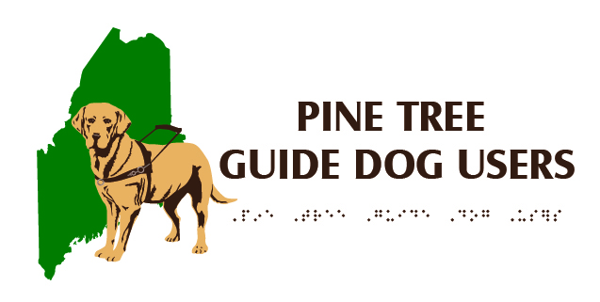

Pine Tree Guide Dog Users (PTGDU)

Opening Doors to Independence and Opportunity
PineTreeGuideDogUsers.org

Mary T. & Curtis D. Lovill Trust

Emergency Veterinary Care Fund Policy

Last Revised November 7, 2024

Purpose
To provide financial assistance to Maine guide dog handlers in need, whose guide dogs require significant, non-routine veterinary services to continue their work.

Terms and Requirements
- Applicants must be Maine residents.
- Applicants may request assistance for veterinary expenses only if those expenses present a financial hardship.
- Routine veterinary services such as wellness visits, vaccines, heartworm/flea/tick preventatives, nail trimming, grooming, etc. do not qualify for financial assistance.
- The treatment must be such that it is likely to keep the guide dog in service for a reasonable amount of time.
- Applicants are responsible for paying the first $250 of the veterinary fees for each emergency.
- Applicants may apply for the portion of the fees over $250, not to exceed $2,500, per emergency.
- Applicants are limited to $2,500 in financial assistance per year, beginning on the day a first application is approved.
- Applicants may only request financial assistance for the portion of the total expense not covered by other funding sources, including guide dog schools, insurance, and veterinary discounts.
- Applicants must submit a completed application within 90 days of the last treatment for consideration by the Board of Directors.
- If financial assistance is awarded, the funds may be paid either directly to the handler for reimbursement, or to the treating veterinarian(s).
- No funds will be distributed until the related invoice(s) have been submitted.

Pine Tree Guide Dog Users (PTGDU)

Emergency Veterinary Care Fund Application

Date:
Name:
Address:
Phone:
Email:
Guide dog school attended:
Age of Guide Dog:
Name of Veterinarian(s):
Description of recommended or completed treatment:

Total invoice amount or estimated cost of treatment:
Amount requested from PTGDU:

By submitting this application, I affirm that to the best of my knowledge and that of my veterinarian, this treatment should extend my guide dog’s service for a reasonable amount of time and that paying over $250 of the cost myself would present a financial hardship.

Please submit completed application with veterinarian’s invoice or estimate to President@PineTreeGuideDogUsers.org. Electronic copies preferred.

